ASSIGNMENT-2

|  |  |
| --- | --- |
| DATE | 17 November 2022 |
| STUDENT NAME | PARESH KUMAR G |
| STUDENT ROLLNO | 95071912065 |

1. CREATE USER TABLE WITH ROLLNO,USERNAME,EMAIL,PASSWORD

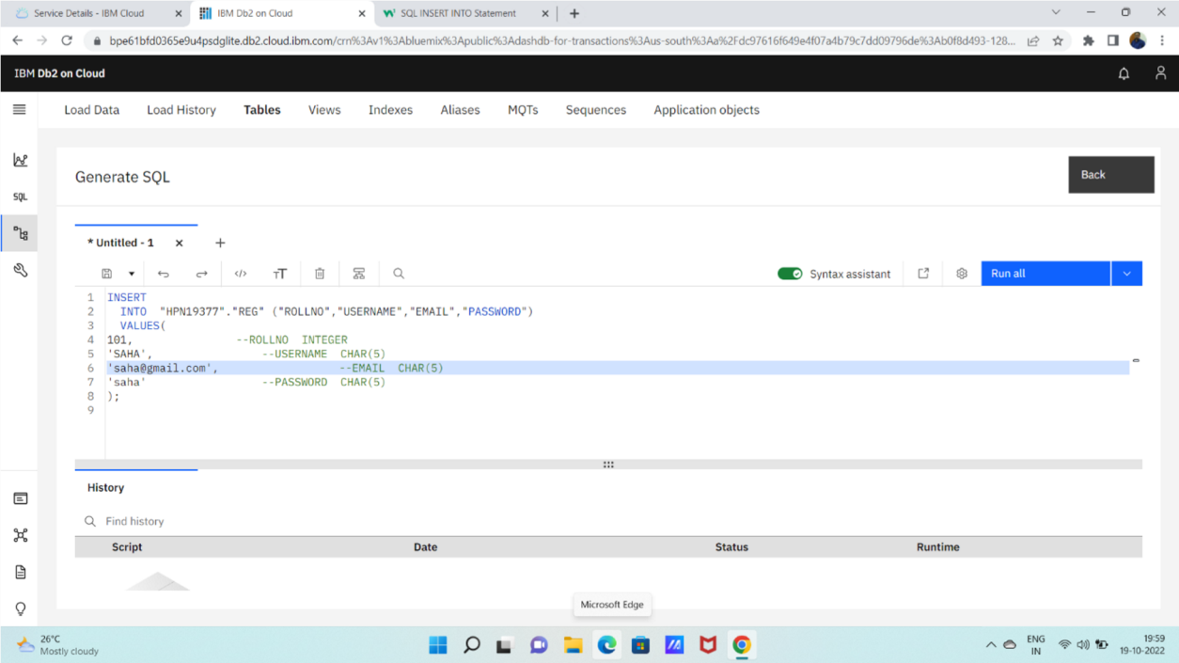

1. PERFORM UPDATE AND DELETE QUERIES:

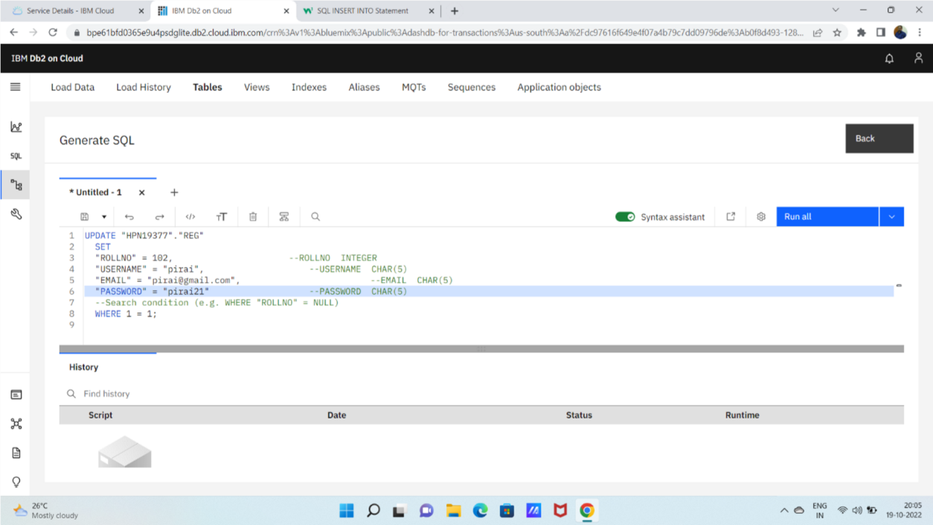

DELETE:

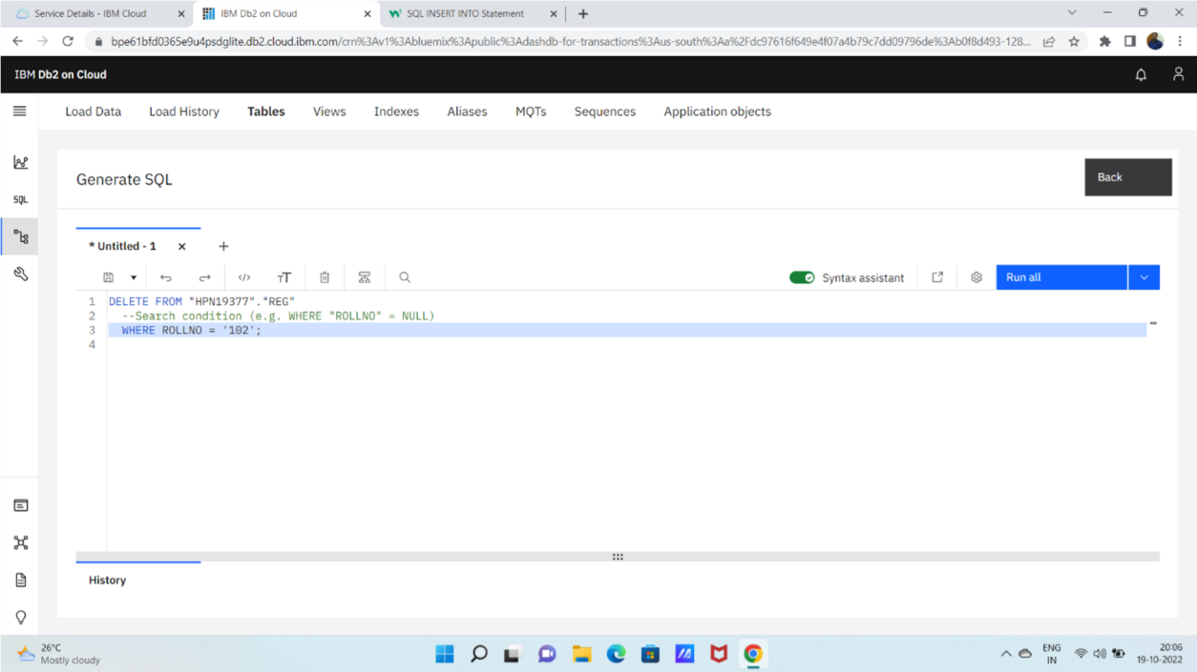

1. CONNECT PYTHON TO DB2:

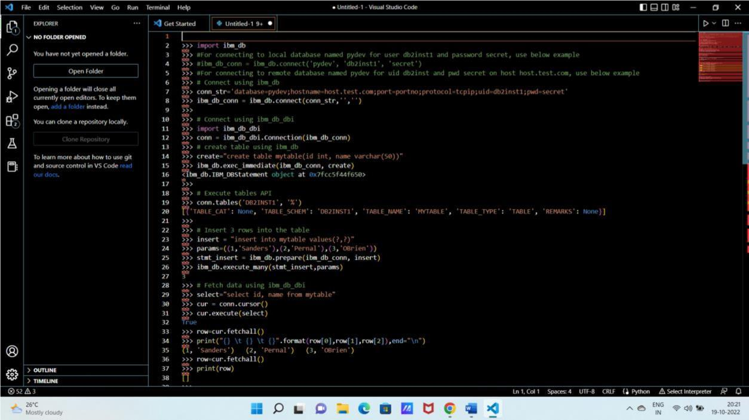

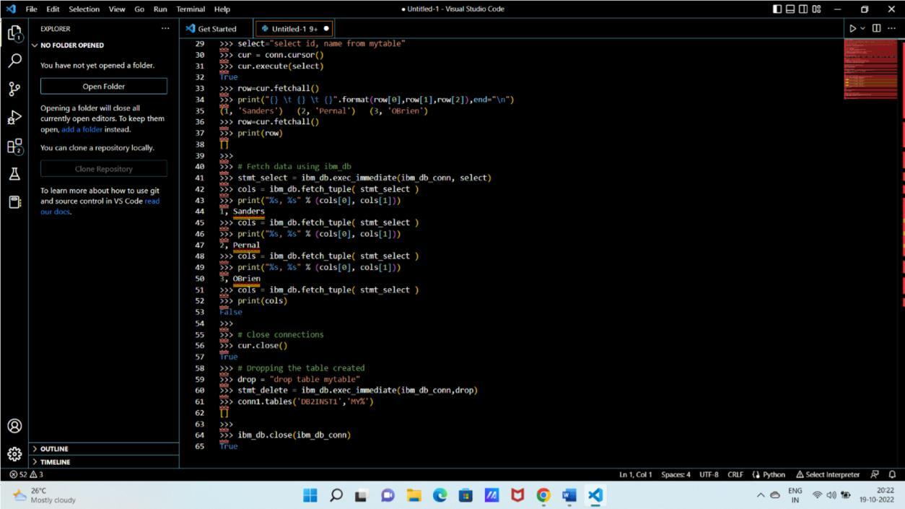

1. CREATE FLASK APP WITH REGISTRATION PAGE ,LOGIN PAGE,WELCOME PAGE

